create database salesdb ;
use salesdb;

CREATE TABLE Sales (
sale_id INT PRIMARY KEY,
customer_name VARCHAR(50),
city VARCHAR(50),
product_name VARCHAR(50),
category VARCHAR(50),
quantity INT,
price DECIMAL(10,2),
sale_date DATE
);

INSERT INTO Sales VALUES
(1, 'Ravi', 'Bangalore', 'Laptop', 'Electronics', 1, 60000, '2023-06-01'),
(2, 'Priya', 'Chennai', 'Mobile', 'Electronics', 2, 20000, '2023-06-03'),
(3, 'Amit', 'Delhi', 'Headphones', 'Accessories', 3, 2000, '2023-06-05'),
(4, 'Neha', 'Mumbai', 'Chair', 'Furniture', 2, 5000, '2023-06-07'),
(5, 'Ravi', 'Bangalore', 'Mobile', 'Electronics', 1, 20000, '2023-06-10'),
(6, 'Priya', 'Chennai', 'Laptop', 'Electronics', 1, 60000, '2023-06-12'),
(7, 'Amit', 'Delhi', 'Chair', 'Furniture', 4, 5000, '2023-06-15'),
(8, 'Neha', 'Mumbai', 'Headphones', 'Accessories', 2, 2000, '2023-06-18');

- Show all records from the Sales table.

select * from sales;
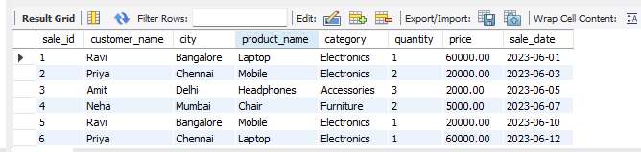
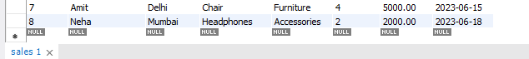

- Display only customer names and cities.

select customer_name,city from sales;

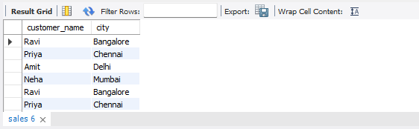
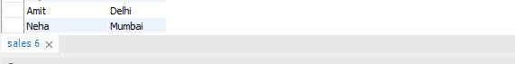

- Show product name and price.

select product_name,price from sales;

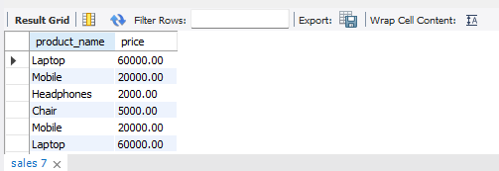
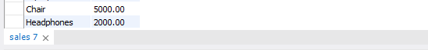

4. Show all sales where city is 'Bangalore'.
select * from sales where city='bangalore';

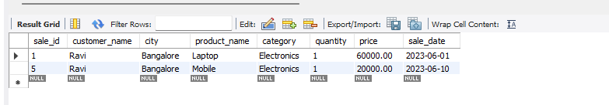

5. Find all products in 'Electronics' category.
select * from sales where category ='electronics';
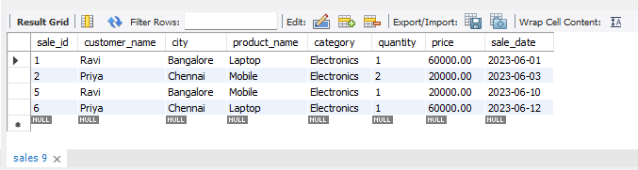

6. Show sales where price is greater than 10,000.

select * from sales where price > 10000;
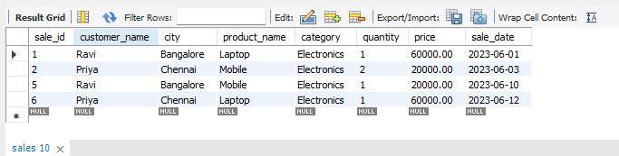

7. Display sales where quantity is more than 2.
select * from sales where quantity >2;

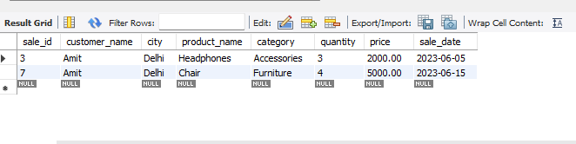
8. Show all sales sorted by price (low to high).
select * from sales order by price asc;

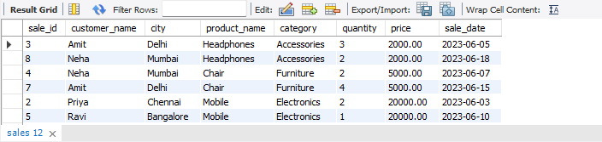
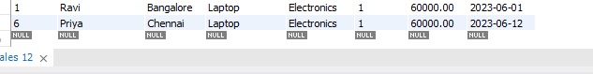

9. Display sales sorted by quantity (high to low).

select * from sales order by quantity desc;

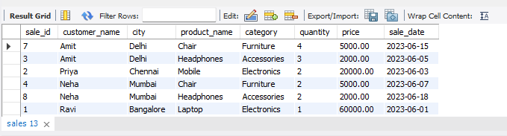
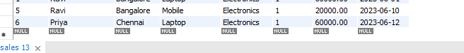

10. Show unique cities.
select distinct city from sales;

